INGZ222 – U6
THE PASSIVE VOICE

https://www.youtube.com/watch?v=QeJzkL7JYMo

Active Voice:
What?
CAEMBA Foundation builds bamboo houses for families affected by the earthquake.
Subject = Doer Object = Receiver

The Passive Voice:

Bamboo houses are built by CAEMBA Foundation for families affected by the earthquake.
Object Subject

You:
The Municipality builds the Metro of Quito. What?
Subject = Doer

Passive Voice:

The Metro of Quito is built by the Municipality
Object (be + vpp) Subject (relevant)

Your example:
Active The mechanic fixes the car
Passive The car is fixed by the mechanic

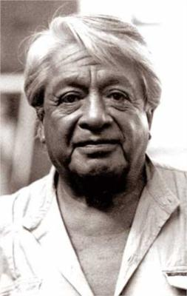
Oswaldo Guayasamín painted “The Age of Anger.” What?
SUBJECT=DOER. v. OBJECT= RECEIVER
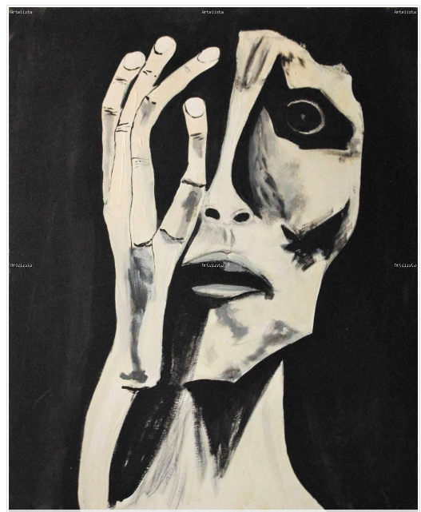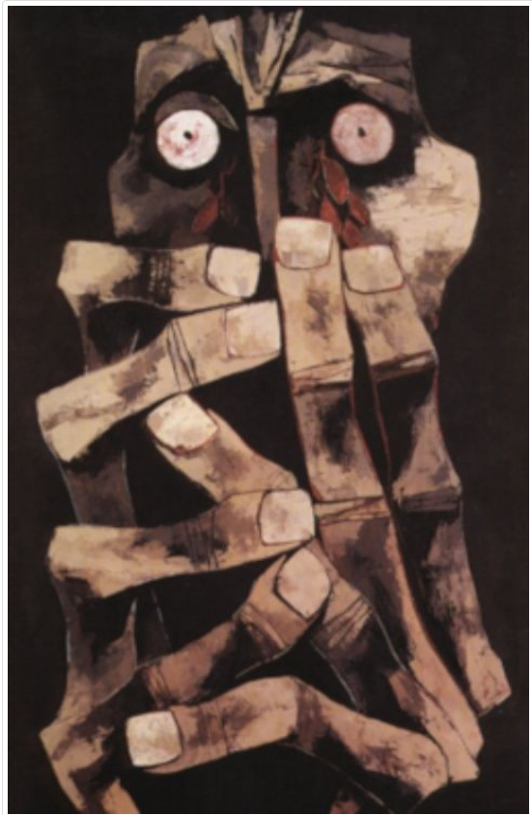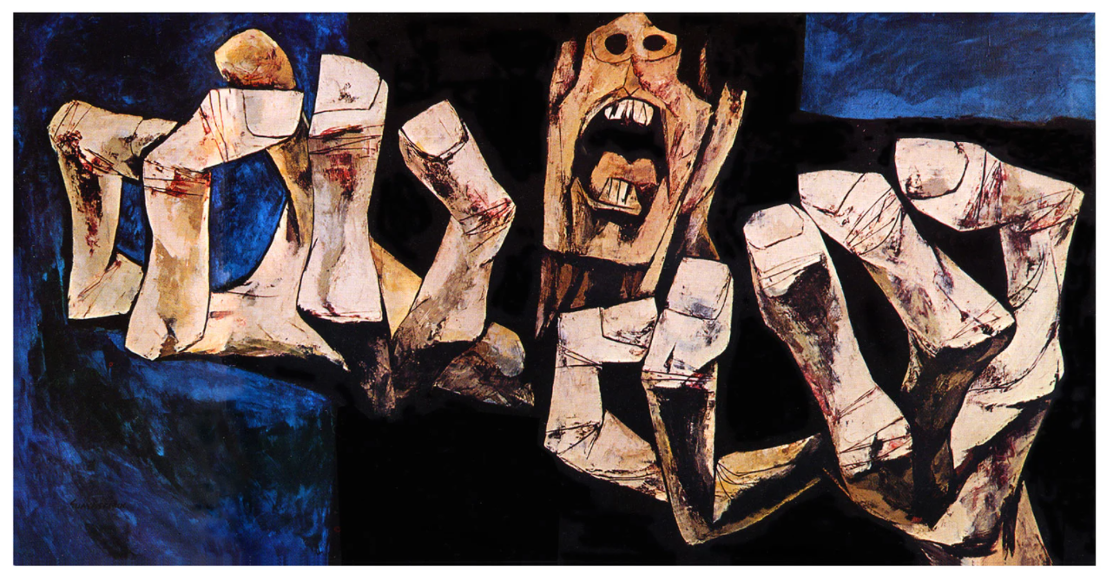
“The Age of Anger” was + painted by Oswaldo Guayasamín.
(it) WAS/WERE + VPP
Passive=OBJECT =receiver= BE+VPP

Active:
William Shakespeare wrote Romeo and Juliette. What?

Passive Voice:

Rome and Julieta were written by _William Shakepeare
Object (was/were + vpp) Subject (relevant)

Your example:
Active A student wrote the articule
Passive The articule was written by a student
My dog ate the sandwich
The sandwich was eaten by my dog

(unimportant or unknown)
They are building the Metro. What?
(unimportant or unknown)

v.
The Metro is being built by them.

The Metro IS being built by them. (unimportant or unknown)

Practice!!

https://www.englisch-hilfen.de/en/exercises/active_passive/sentences_mixed.htm

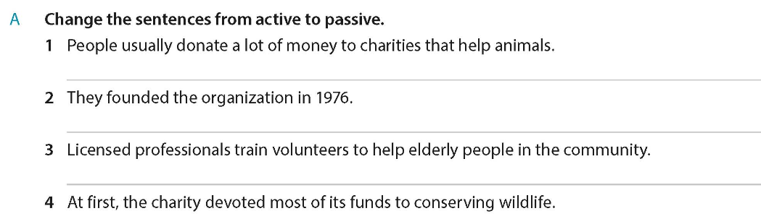
- A lot of money is donated to charities that help animals.

- The organization was founded in 1976 .

- Volunteers are trained by licensed professionals to help elderly people in the community.

- Most of its funds were devoted to conserving wildlife.

Do Cambridge One.

